IOT BASED SMART WATER MANAGEMENT

A Project report submitted in partial fulfilment of the requirements for the degree of B. Tech in Information Technology

By

T. RAMYABHARATHI (513221205014)

Under the supervision of

Professor & HOD

Department of Information Technology

Smart Water Management

**PHASE-5 PROJECT DOCUMENTATION AND SUBMISSION**

**Problem statement:**

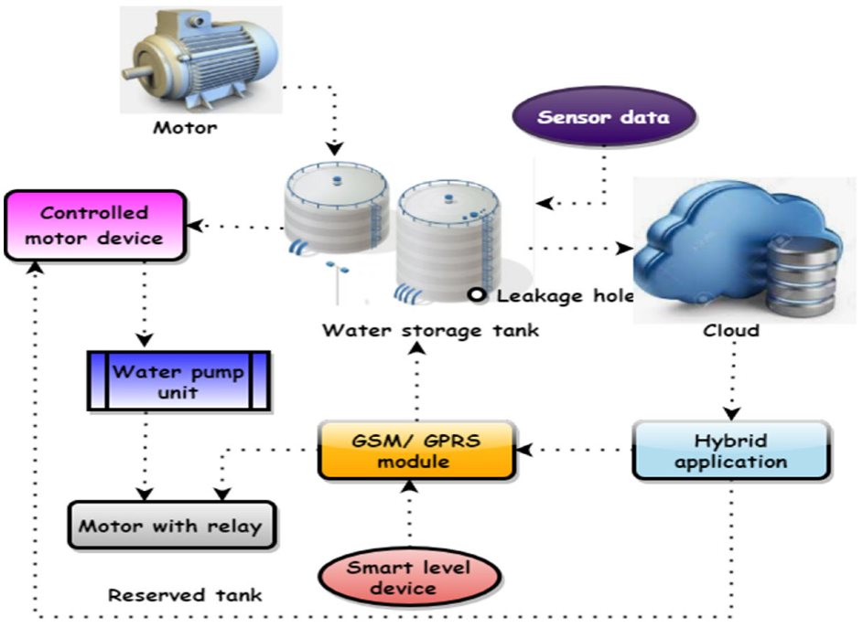

In the 21st century, there were lots of inventions but at the same time were pollutions.

Global warming and so,

on are being formed, because of this there is no safe

drinking water for the world’s pollution. Nowadays, water

quality monitoring in real time faces challenges because of

global warming limited water resources, growing

population, etc. Hence there is need of developing better

methodologies to monitor the water quality parameters in

real time. The monitoring of water quality is extremely

important for maintaining the safety of water resources used

for various purposes.

IoT is progressing with millions of things

connecting each day to generate large amount of

information .

(Internet of Things) based water quality monitoring has been

proposed. In this project, we will implement the design of

IOT for monitoring system that monitors the quality of

water in real time.*A. Micro Controller-* TheAtmega328isa one of thevery popular

microcontroller chip produced by Atmel It is

an 8 -bit microcontroller that has32Kof flash memory,1K Of EEPROM,and2K ofSRAM.The Atmega328 is one of the microcontroller chips that are used with the

popular Arduino boards.This microcontroller

hasanalogpin and digital pin for easy interface of the

=MicrocontrollerOperating Voltage: – 1.8 - 5.5V23

Programmable I/OLinesTwo 8-bit Timer/CountersReal

Time Counter with Separate OscillatorSix PWM Channels6-

channel 10-bit ADC .

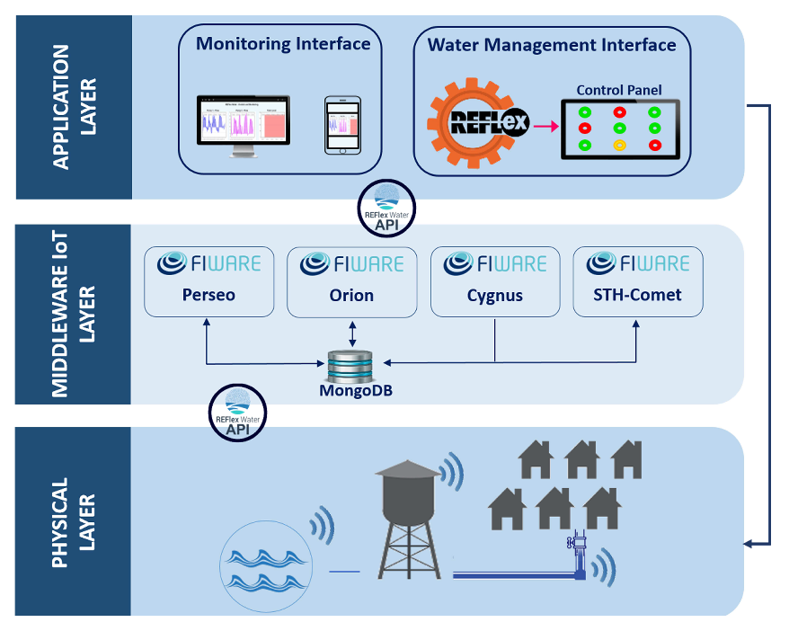

*B.IOT Module*

Wi-Fi Direct (P2P), soft-APIntegrated TCP/IP protocol

stack+19.5dBm output power in802.11b modeSupports

antennadiversityPower down leakage current of <10Ua

Integrated low power 32-bit CPU could be used as

application processorSDIO 2.0, SPI, UARTWake up and

transmit packets in <

2msStandby power consumption Operating Voltage :

Is exceed and it is burn the esp module. GND is connected to

the ground terminal. Rx pin is the receiver pin UART serial

communication The Tx pin is a transmitter. GPIO general

purpose input and output .Reset pin reset the module apply in

3.3v. the CH-PD pin configure channel.

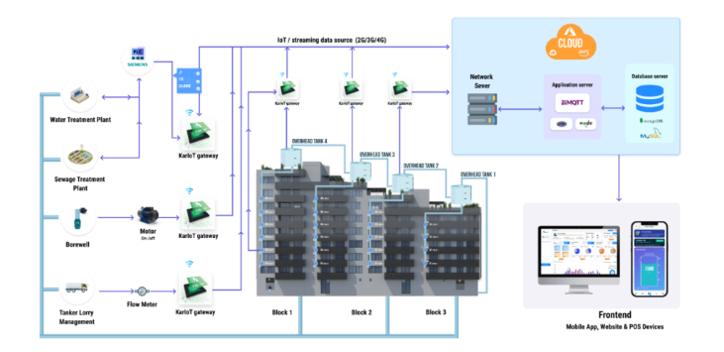

**Design Thinking approach**

**MISO** pins on both the master and slave are ties together.

Even though the Signal in MISO is produced by the Slave,

the line is controlled by the Master . The Master generates a

clock signal at SCLK and is supplied to the clock input ofthe slave. Chip Select (CS) or Slave Select (SS) is used to select a particular slave by the master.

Master – Out / Slave – In or MOSI, as the name suggests, is

the data generated by the Master and received by the Slave.

Hence, MOSI pins on both the masterand slave are

connected together. Master – In / Slave – Out or MISO is

the data generated by Slave and must be transmitted to

Master.

Configuration of nRF24L01

RF24 radio (CE, CS) --- mention the pin connection

Mention the pipe address

Uint64_t pipe = 0xE8E8F0F0E1LL

Radio.begin (); Start the process

Radio.openWritingPipe (pipe)

Radio.write(msg,1); Radio.startlistening();

Radio.available() – to check any incoming message.

It is used to monitoring the salt content of the sewage water

and communicate with microcontroller for posting this

information to internet. It has consists of two rods one is

reference rod and measuring rod. The voltage is given to the

reference rod and the conducting current passes to

measuring rod. The voltage present in the measuring rod is

proportional to the salt content of the water.

The turbidity sensor SKU: SEN0189 is used to detect

water quality by measuring level of turbidity. The

turbidity sensor enables the detection of suspended

particles in water.

To the microcontroller unit (MCU). The threshold is adjustable by

adjusting the potentiometer in digital signal mode. The operating

voltage of the turbidity sensor is 5V DC and the operating current

is 40mA (max) respectively.

* Sensus provides water suppliers and utility networks with sensor and data solutions for smart water management. Their toolkits include hardware for smart metering and reading, data analytics and customer portals as well as specific solutions for leak prevention and regulations compliance.

**Rain and stormwater management**

### Companies like [Raingrid](https://www.raingrid.com/) turn rain and stormwater into a water resource able to fully provide water needs for independent households and the whole neighborhoods. The company designs and implements IoT and data solutions to harvest rainwater and transform it into a major water source for off-grid communities.

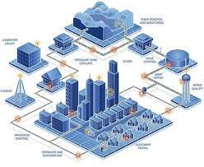

This approach shows how the application of Internet of Things in water resources management helps unlock the new options for more sustainable and resilient living.

### Smart water monitoring

[Adcon](https://www.adcon.com/solutions/) is a smart water company that provides a wide range of water management services from leakage detectors to irrigation management and rainwater monitoring. One of the company’s solutions is focused on smart water measurement and quality monitoring for different businesses in the supply chain — farmers, meteorologists, utility services, etc. The solution includes sensors, stations, telemetry units and software which processes generated data and creates insights for the decision-makers. At Digiteum, we design and develop IoT software and big data applications for sustainable and resilient use of resources.

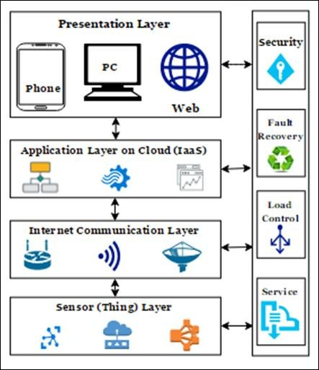

### Benefits of using IOT For Water Management

IoT solutions for water management help industry stakeholders, governments and average consumers reach their sustainability and efficiency objectives. Today, the concept of IoT in this sector already translates into a brand new idea — the Internet of Water. It requires connecting all the systems and players in the water supply chain — water sources, treatment plants and industrial water management systems, distribution facilities, utility and clean energy companies, and consumers, etc. and empowering decision-makers with important insights on the state of water resources and equipment used in the supply chain.

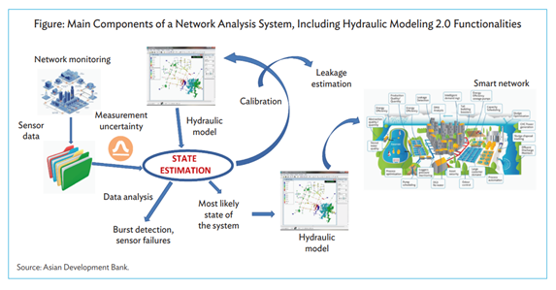

In the present era, IoT provides support for multiple industries which is subjective with smart water management solutions. These solutions preserve the overall maintenance and usage of resources. SCADA stands for Supervisory Control and Data Acquisition regulates water distribution systems. SCADA is installed within the overall system. By integrating [**smart water management using IoT**](https://www.karikala.in/) sensors, controlling leakage is feasible in real-time. A series of equipment like water sensors, IoT water flow meters, valves, and irrigation controllers track different measurements like water pressure, temperature, control of water, etc. The collective data of the IoT smart water management system helps multiple firms to analyze information related to real-time water resources. The IoT-enabled smart water management methodologies eradicate maintenance & operational cost.

**Smart water management using IoT** provides the solution for the firms to regulate water flow by interconnecting smart sensors and smart meters. The main role of the sensors and meters is to collect water flow data and generate analytical water performance reports. With the aid of web dashboards, industries observe the utilization of water.

Smart water management aids to reduce water usage consumed in enormous amounts for different fields like agriculture, production sector, agriculture, etc. It contemplates the multiple practices of farming, agricultural applications, farming, etc. Mostly everyone has started to enforce agriculture software to process the tasks.

Water pollution is one of the biggest threats to all living beings. No wonder there is a huge need to monitor water quality using technology. The article shines a light on what an IoT-based Smart Water Quality Monitoring (SWQM) system is, its five hardware components and benefits, along with the main challenges in watermanagement

. 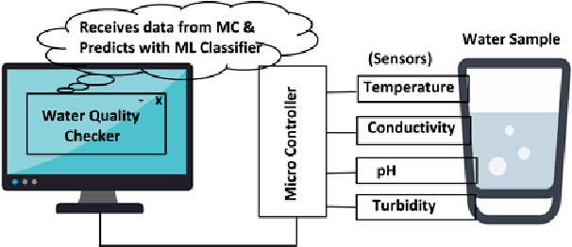

Safe water is rapidly becoming a scarce resource thanks to the combined impact of increased population, pollution, and global warming. Speaking of water pollution, it is one of the biggest obstacles to green globalization.

To ensure the continuous drinking water supply, its quality needs to be monitored in real-time. Traditionally used laboratory-based testing techniques are time-consuming and costly because they must be undertaken manually.

Even though water monitoring systems have seen some advancement, they utilize the wireless sensor network or wireless network technology that comes with their share of problems, including weakness in data security, communication coverage, and energy consumption management.

That is why the Internet of Things (IoT) has been a boon in this regard, as it enables the current developments of more efficient, secure, and cost-effective systems with real-time capabilities.

SWQM is the process of measuring the water quality parameters, such as temperature, pH, turbidity, dissolved oxygen levels, variety of ions present, and so on. The main objective of monitoring water quality is to ensure these parameters are within a suitable range.

The traditional method of water monitoring was done physically, using only chemicals. A water quality monitoring application involves using different [IoT-based smart sensors](https://www.intuz.com/guide-on-top-iot-sensor-types) that keep track of the parameters in real-time.

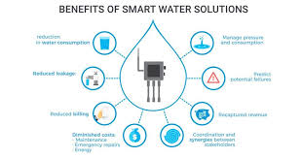

As mentioned previously, the traditional modes of monitoring drinking water quality required manual effort and comprised chemical testing. They were costly and time-consuming and did not have any scope of receiving results in real-time.

However, wireless communication developments soon created new sensor capabilities. In such systems, field technicians would measure a few water parameters on-site using portable sensors, which were easy to transport and use in the field.

Although such a field of sensor networks improved the testing bit to an extent, most of the issues mentioned earlier did not go away. With time, WSN technology gained prominence, allowing receiving feedback on testing in real-time.

However, the network was prone to cyberattacks and had poor data security. The communication speed was low, and the installation and maintenance costs were high.

Sure, the WSN systems were much better than the traditional methods of monitoring of water pollution, but there was scope for improvement.

As IoT allows connected devices to store and exchange data conveniently, the technology has found a way to contribute to environmental issues besides the automation industry. Today, it incorporates some mechanism for monitoring the quality of water over a period of time.

